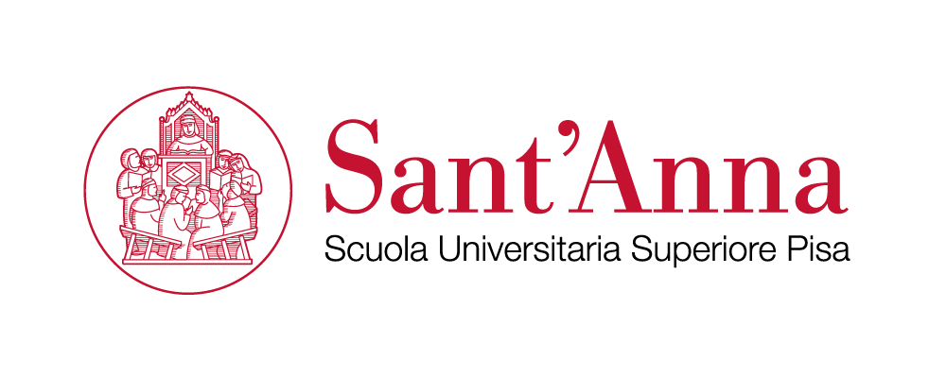

International Standards for the
Protection of Individuals and Groups:
A Training Course for Officers Working on Human Rights

Pisa, 15-22 November 2021

APPLICATION FORM
TO BE FILLED ELECTRONICALLY BY THE APPLICANT
(upload it at the following link where requested: )

Place your photo here or send it as an attachment.

Family Name |  | Citizenship
Forename(s) |  | Date of Birth (yyyy/mm/dd)

Personal Details

Sex
Place of Birth
Passport Number
Mailing Address

Street

Postal Code + City

Country

Telephone

Work

Home

Mobile (compulsory)

Fax
E-mail (compulsory)
Emergency Contact

Name
- Address
- Contact Numbers

Higher Education

Name and Location of University or Institution | Length of Studies  (in Years) | Diploma or Degree Obtained

Attendance of relevant Training, Seminars, etc.

Year | Country | Institution | Type of Training, Seminar, etc.

Professional Background

Civilian
Military
Police

General Professional Experience (starting with most recent – please give details)

Date  (from mmyy to mmyy) | Country | Organisation – Company | Title of Position | Main Tasks  (Short Description)

Language skills (please start with your native language)

Language | Scale 1 – 3 (1 = Basic; 2 = Good; 3 = Excellent)
 | Understood | Spoken | Written | Read

Former mission experiences and / or related skills.

Please outline your reasons (motivation) for attending the course and your intentions with regard to future peace building activities (not more than 300 words)

Declaration of the Applicant:

By submitting this “Application Form” I confirm that all the information given in this form is correct and complete. I also confirm that I agree to the following conditions of participation:
- I am motivated, willing and available to engage in all activities during the training.
- I understand that due to the extensive character of the training course, late arrival or early departure is not acceptable.
- I accept that the intensive character of the programme does not allow for any additional commitments during the course.
- I understand that the training institution reserves the right to exclude the participant from the course in case information given in the form proves to be incorrect (i.e. insufficient language skills) or because of misconduct at the training site.

Privacy Note: We are concerned about the privacy interests and therefore committed to respecting privacy by using any personal information gathered in the most responsible way. The collected personal data will serve only for the purpose of participation in the training.

